Skrimp Shack Food Truck Menu 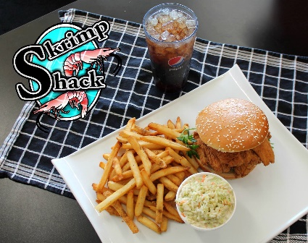
Whiting Sandwich 5- 6 pieces of flaky white meat fish on a sesame seed bun $8.50
Catfish Sandwich 3-4 meaty filets on a sesame seed bun $9.00
Skrimp Po Boy 15 shrimp on a 6 inch hoagie roll, topped with our special PO sauce $11.50
Skrimp & Crab Po Boy 15 shrimp topped with crab meat on a 6 inch hoagie roll, topped with our special PO Boy sauce $11.75
Skrimp Tacos w/ Po Boy Sauce 2 tacos with filled with 6 shrimp, topped with lettuce, cheese and our special PO sauce $9.00
Make a Combo (incl. side & drink ) $4.00
Skrimp Basket (incl side & drink) 12 large shrimp w/ cocktail sauce, side & drink $12.50
Chicken Basket (incl side & drink) 5 chicken strips w/ PO Boy sauce, side & drink
$9.50
A-La-Carte
Crab Balls 4 homemade crab filled balls, deep fried & served with cocktail sauce $5.50
French Fries lightly salted, deep fried to a golden brown $3.00
Mac & Cheese creamy white cheddar cheese $3.00
Cole Slaw homemade sweet & tangy $3.00
Drinks: Soda $2.00, Water $1.00
Tax not included

